 |  |  | Why do people invade and settle?  Year 5 Crew  Knowledge Organiser  Terms 5 and 6  Enquiries  What is invasion?  Why do people invade?  Why did the Vikings travel?  What did the Vikings trade?  How did invasion and settling change Britain?  Key Facts  Old Norse language was spoken in Scandinavia.  Norway, Denmark and Sweden make up Scandinavia.  Some of the most famous Vikings were Danes.  The places Vikings settled in were known as Danelaw.  The Norwegians raided Scotland, and founded Iceland.  Britain was divided into different kingdoms during the Anglo Saxon reigns.  King Alfred allowed the Vikings to settle in York and East Anglia ruled by the Viking King Guthrum.  Vikings settled in the Orkneys, Hebrides, around the north and north west of Scotland, Parts of Ireland (Dublin is a Viking city), the Isle of Man, Northumbria, East Anglia etc.  Places ending in by and thorpe were places Vikings settled.  Vikings were also known as Norsemen. They were great travellers who sailed to parts of Europe where they traded, raided and often settled.  Vikings sailed in longships which could sail in shallow water and land on beaches. They could sail up rivers as well as the sea and were light enough to be carried on land.  Vikings were also farmers, fishermen, trappers, traders, and skilful craftsmen with textiles, wood, metal and bone.  Danegeld was a tax raised to protect against Viking invasion  Anchor texts  Riddle of the Runes by Janina Ramirez  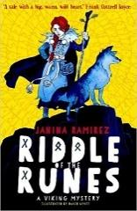 |   
Vocabulary
History | Anglo-Saxons | People who lived in England before and during the Viking reign.
History | Danegeld | A tax introduced to protect against Viking invasion. |  | Key Dates  Vikings were invaders and settlers who came from Scandinavia and travelled by boat as far as North America in the west and Central Asia in the east from about 700 AD to 1100.  The Viking age began in the 9th Century and lasted for just over 200 years.  793 The first Viking invasion was the monastery of Lindisfarne  886 King Alfred, Saxon king of Wessex defeated the Vikings in a great battle  1066 The Vikings of Normandy (Norsemen) finally conquered England and changed British history.  Leif Erikson led a Viking crew to North America around 1000 years before Christopher Columbus.  Diagrams  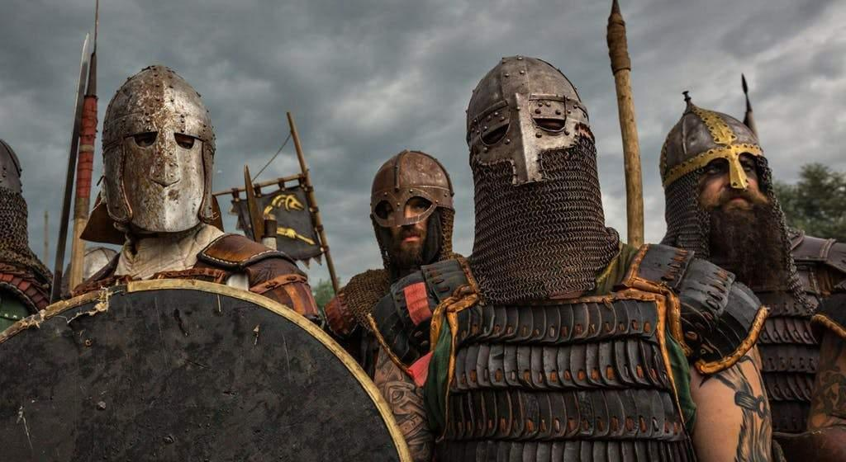  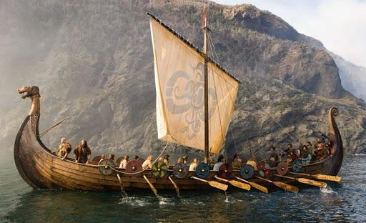
History | Danelaw | A part of England ruled by Danish law.
History | Invasion | Taking over another country with force.
History | Lindisfarne | A holy island off the northeast coast of England.
History | Longship | A type of ship that made the Vikings raids so successful.
History | Norse Gods | The Gods the Vikings believed in
History | Norsemen | Another term for ‘Viking’.
History | Viking | Pirate Raid
Geography | natural resources | resources that exist without being developed by humans
Geography | Scandinavia | The area of the world where Vikings originated.
Art and Design | binca | a fabric for sewing
Art and Design | cartoons | drawings that tell a story
Art and Design | embroidery | using a needle and thread to decorate fabric
Art and Design | Marvel Comic Art | a particular style of art form the Marvel comic series
Art and Design | model | to copy or show what a ‘thing’ may look like
Art and Design | motif | an image or design
Art and Design | thread | a long thin strand of cotton
Art and Design | enlarge | make something larger in size
Art and Design | reduce | make something smaller

