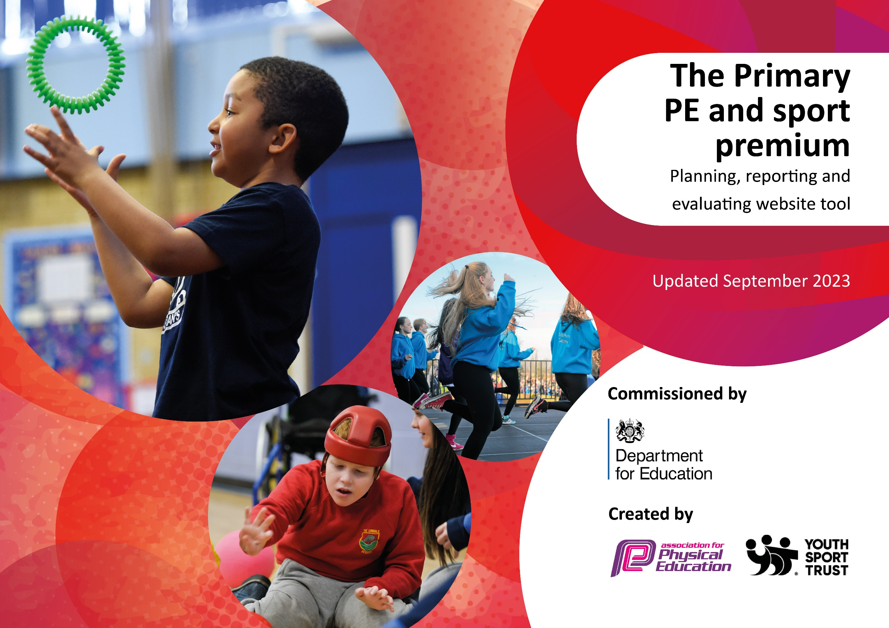

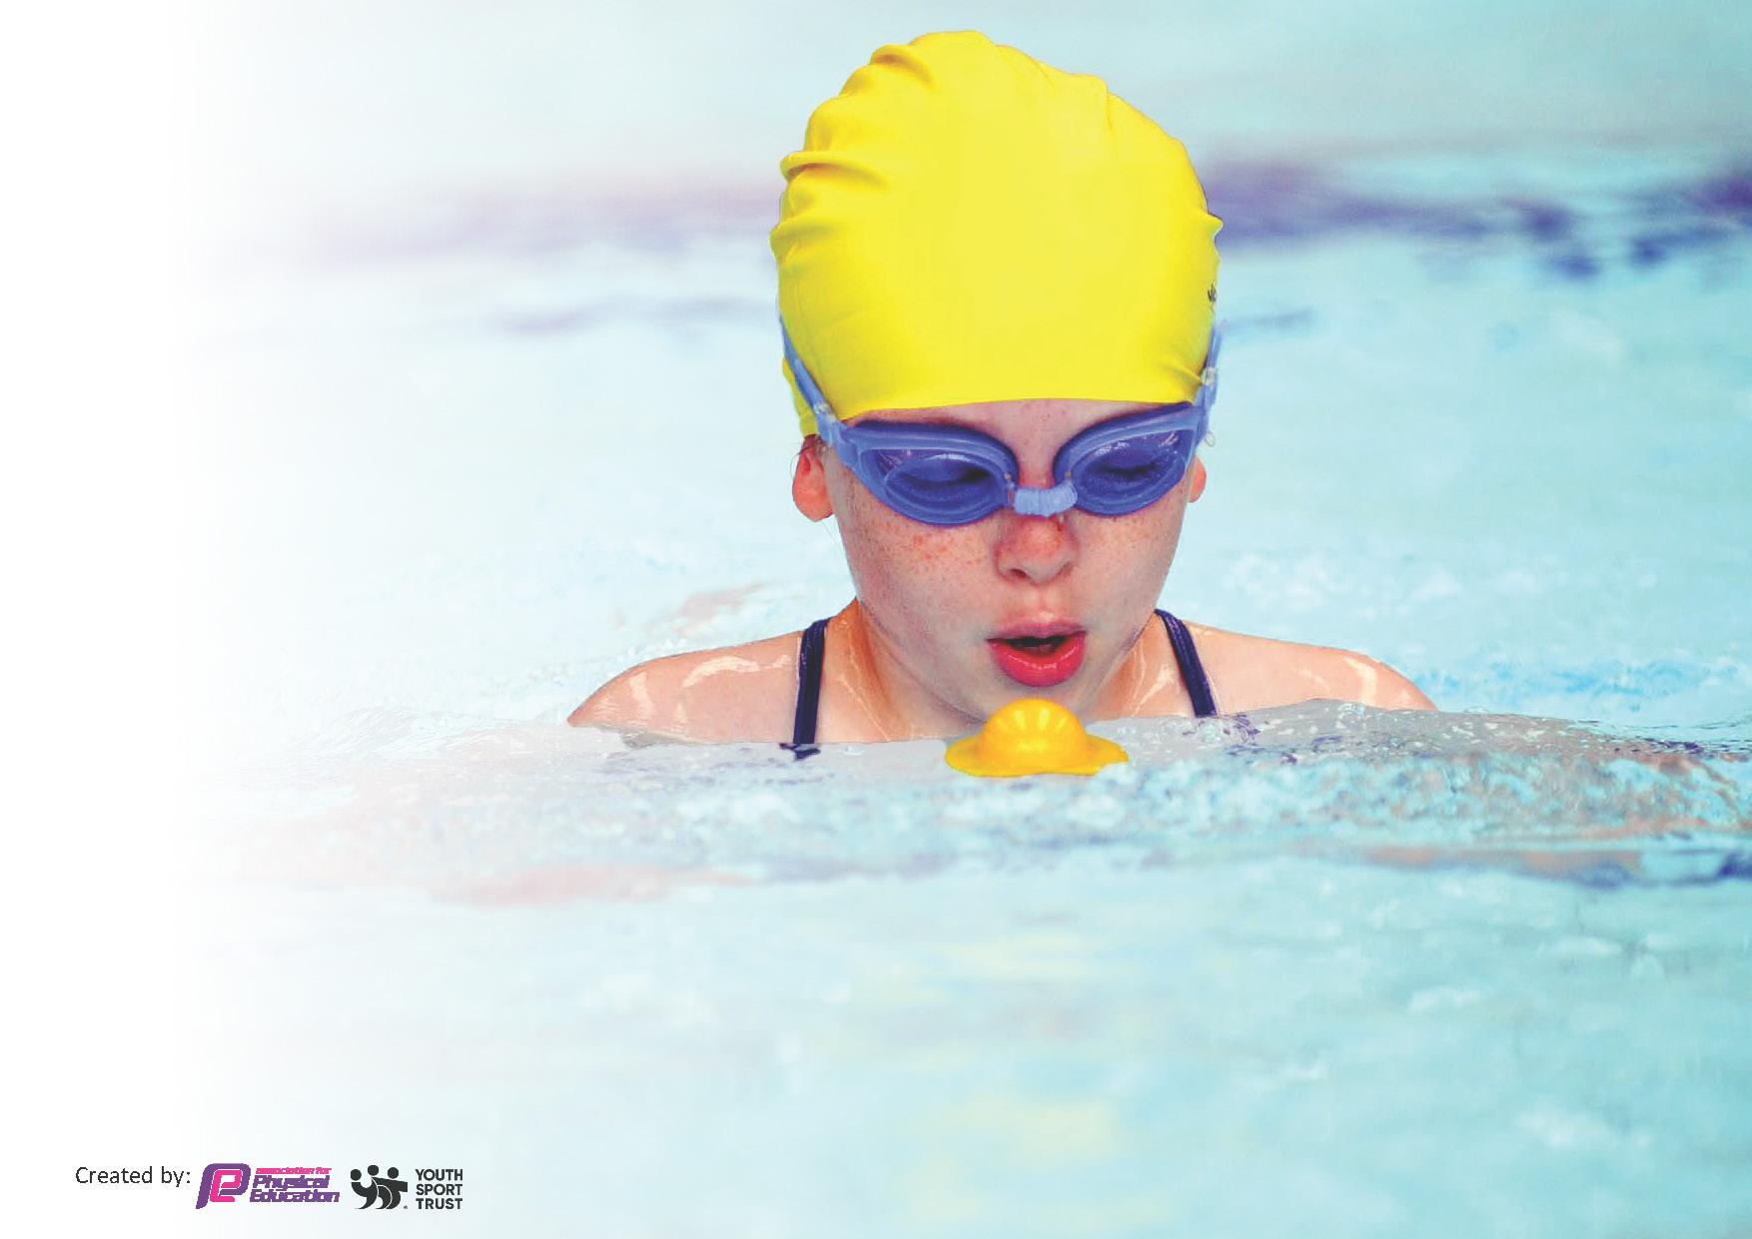
This template can be used for multiple purposes:
by:
- It enables schools to effectively plan their use of the Primary PE and sport premium
- It helps schools to meet the requirements (as set out in guidance) to publish information on their Primary PE and sport premium
- It will be an effective document to support Ofsted inspections enabling schools to evidence progress in Physical Education (PE) and evidence swimming attainment, which forms part of the PE National Curriculum. We would recommend schools consider
the Intent, Implementation and Impact of any spend, as examined within the Education Inspection Framework.

It is important that your grant is used effectively and based on school need.

Schools must use the funding to make additional and sustainable
improvements to the quality of the PE, School Sport and Physical Activity (PESSPA)
they offer. This means that you should use the Primary PE and sport premium to:

- Build capacity and capability within the school to ensure that improvements made now will benefit pupils joining the school in future years
- Develop or add to the PESSPA activities that your school already offers.

The Primary PE and sport premium should not be used to fund capital spend projects; the school’s core budget should fund these. Further detail on capital expenditure can be found in the updated Primary PE and sport premium guidance.

The Primary PE and sport premium guidance, outlines 5 key priorities that funding should be used towards. It is not

necessary that spending has to meet all the key priorities, you should select the priorities that you aim to use any funding towards.

Although completing this template is not a requirement for schools, schools are required to publish details of how they spend this funding. Schools must also outline what the impact this funding has had on pupils’ PE and sport participation and attainment and how any spending will be sustainable in the future. All funding must be spent by 31st July 2025.

The Department for Education has worked closely with the Association for Physical Education (afPE) and the Youth Sport Trust (YST) to develop this template and encourages schools to use it. This template is an effective way of meeting the reporting requirements of the Primary PE and sport premium.
Review of last year’s spend and key achievements (2023/2024)

We recommend you start by reflecting on the impact of current provision and reviewing your previous spend.

Activity/Action | Impact
Key Indicator 1: Increased confidence, knowledge and skills of all staff in teaching PE and sport  Key Indicator 2: The engagement of all pupils in regular physical activity.  Key Indicator 3: The profile of PESSPA is being raised across the school as a tool for whole school improvement  Key Indicator 4: Broader experience of a range of sports and activities offered to pupils.  Key Indicator 5: Increased Participation in competitive sport | - All teachers had access to a variety of workshops which were run by external organisations to support with the delivery of sports they are less confidence with.  - Staff are actively using REAL PE scheme to enhance PE provision.  - Staff are actively using Complete PE scheme to enhance PE provision  - 100% of staff have a clear understanding of how to teach PE in their year group.  - All pupils in all year groups have two hours of physical activity timetabled in to their school week.  - All children had opportunities during lunchtimes to take part in different and accessible activities led by the Year 6 Young Sports Leaders.  - Children use the play equipment during playtimes and lunchtimes.  - Offered a huge variety of sporting/active events an activities across the week. Some which they had done before and some which were new, more unusual activities. Lots of positive feedback from the week and children felt they had a chance to try new things.  - Children have been given opportunities to attend sporting events across the school year.  - Children have opportunities to attend afterschool sporting clubs delivered by both staff and outside specialist outside agencies.  - Children have had opportunities to take part in competitive sports through the NSSPEA.  - After school football club was lead on both sites and they had a inter-site match to encourage competitive sport.

Key priorities and Planning
This planning template will allow schools to accurately plan their spending.

Action – what are you planning to do | Who does this action impact? | Key indicator to meet | Impacts and how sustainability will be achieved? | Cost linked to the action  £19,360
Continue to offer lunchtime sport sessions/activities for pupils through young leaders.  Continue to offer breakfast sports club.  More play equipment  Ensure that all year groups are offered competitive opportunities. | Play leaders supporting Young sports leaders  Pupils who will take part.  Pupils who will lead.  Play leaders who will supervise.  Play Leaders who will facilitate.  Pupils who will participate – all children to have the opportunity over their primary school period. | Key Indicator 1: Increased confidence, knowledge and skills of all staff in teaching PE and sport  Key indicator 2: Engagement of all pupils in regular physical activity.  Key indicator 4: Broader experience of a range of sports and activities offered to all pupils.  Key indicator 4: Broader experience of a range of sports and activities offered to all pupils.  Key indicator 5: Increased participation in competitive sport. | More pupils meeting their daily physical activity goal, more pupils encouraged to take part in PE and Sport Activities.  Sports leaders have continued to provide PEP by ensuring that children always have access to well-planned and thought out activities, using a range of equipment during every break and lunchtime. Using skills learnt through their ‘Sports Leaders Course’  NSSPEA membership to be continued. | Sport’s leaders course.  £209.00  Playground Markings  £600+  Staffing  £8000  Lin money?  £1834.20

CPD for teachers to improve teaching and learning  Intersite Competitive competitions.  Healthy Me Week  Swimming | Primary generalist teachers.  Early Career Teachers (ECTs)  Secondary colleagues in the trust supporting primary’s.  Staff who will lead session  Pupils who will have the opportunity to take part.  Pupils who will take part. Teachers who will gain experience in leading a sporting event.  Pupils across the schools. Staff are given the opportunity to watch others in their field of expertise to enhance their own understanding.  Year 3 pupils who will swim for a total of 10 sessions. | Key Indicator 1: Increased confidence, knowledge, and skills of all staff in teaching PE and sport.  Key Indicator 3: The profile of PE and sport is raised across the school as a tool for whole school improvement.  Key indicator 5: Increased participation in competitive sport.  Key Indicator 1: Increased confidence, knowledge, and skills of all staff in teaching PE and sport.  Key indicator 2: Engagement of all pupils in regular physical activity.  Key Indicator 3: The profile of PE and sport is raised across the school as a tool for whole school improvement.  Key indicator 4: Broader experience of a range of sports and activities offered to all pupils.  Key indicator 5: Increased participation in competitive sport.  Key indicator 4: Broader experience of a range of sports and activities offered to all pupils. | Primary teachers more confident to deliver effective.  Teachers to use their new skills to support an after school club, giving children more opportunities to undertake extra activities inside and outside of school.  PE supporting pupils to undertake extra activities inside and outside of school.  This week is the second annual event which incorporates competitive elements of sport, through our site sport’s days; habit changes, through our walk/cycle to school initiatives; mindfulness and self-care inspiration through visitors, and workshop; an exposure to lesser known sports and activities; workshops from our partners as NSSPEA to give children chance to take part in festivals and multi-skills activities; links to our local sports clubs to boost engagement in out-of-school activities; young leaders from local link secondary schools to support their courses and give opportunities to lead; fitness fun for all children to be involved with. | £200  £30  £1000  £3635

Key achievements 2024-2025
This template will be completed at the end of the academic year and will showcase the key achievements schools have made with their Primary PE and sport premium spending.

Activity/Action | Impact | Comments

Swimming Data
Meeting National Curriculum requirements for swimming and water safety.
Priority should always be given to ensuring that pupils can perform safe self-rescue even if they do not fully meet the first two requirements of the National Curriculum programme of study

Question | Stats: | Further context  Relative to local challenges
What percentage of your current Year 6 cohort can swim competently, confidently and proficiently over a distance of at least 25 metres? | 80% | Use this text box to give further context behind the percentage.  e.g., 30% - we are struggling to get pool space due to our local pool closing so we have had to use a much smaller local school pool. We have had to limit the number of pupils attending swimming lessons during one term which means some pupils have attended fewer swimming lessons than others.
What percentage of your current Year 6 cohort can use a range of strokes effectively [for example, front crawl, backstroke, and breaststroke]? | 64.3% | Use this text box to give further context behind the percentage.  e.g., Even though your pupils may swim in another year please report on their attainment on leaving primary school at the end of the summer term 2024

What percentage of your current Year 6 cohort are able to perform safe self-rescue in different water-based situations? | 58.6% | Use this text box to give further context behind the percentage.
If your schools swimming data is below national expectation, you can choose to use the Primary PE and sport premium to provide additional top-up sessions for those pupils that did not meet National Curriculum  requirements after the completion of core lessons. Have you done this? | Yes/No
Have you provided CPD to improve the knowledge and confidence of staff to be able to teach swimming and water safety? | Yes/No | We have 2 qualified swim teachers amongst our staff, whom will lead the children in their swimming lessons alongside the swim teachers from the local leisure center. Their qualifications are kept up to date.

Signed off by:

Head Teacher: | Emma Hardy-Smith
Subject Leader or the individual responsible for the Primary PE and sport premium: | Kieran Webster  PE Lead
Governor: | (Name and Role)
Date: | 23rd September 2024

