 |  |  | What do other countries look like compared to ours?  Busy Bees  Knowledge Organiser  Terms 5 and 6  Provocations  Eddie the Explorer will be visiting Busy Bees on Monday 15th April. We will be finding out about what an explorer does.  We will also be looking at maps and learning about the symbols for physical (natural) and human (man-made) features. We will be drawing our own maps of our environments.  We will be discussing the need to look after our fragile world and asking what we can do to help keep our world safe and beautiful for everyone and everything. We will be comparing life in this country to the countries of Spain, Iceland, Kenya and Australia by looking at the similarities and differences in climate, clothing, language, food, homes, landmarks and animals.  Mini Enquiries  What is our environment like?  What differences do we see between where we live and Iceland?  What differences do we see between where we live and Spain?  What differences do we see between where we live and Kenya?  What differences do we see between where we live and Australia?  What have we learnt from our exploration of the world? | 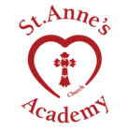
Vocabulary
Key Words | Similar | Environment
 | Natural | Contrasting
 | Features | Landmark |  | Anchor Texts  Books about our world  (Here are some examples but please use any books you have at home or find at the library.)  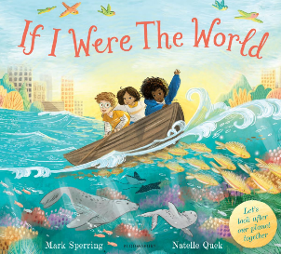  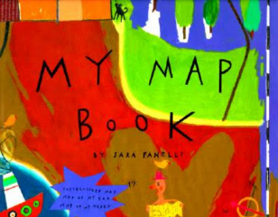  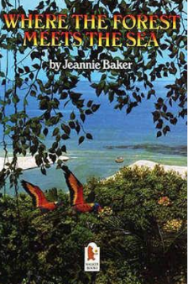  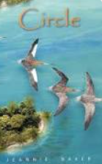
 | Physical | Human
 | Symbol | Explorer
 | Trust | Service
 | 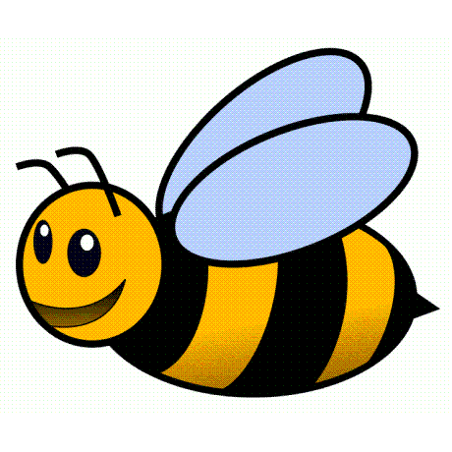 | 