What helps living things grow and change?

Busy Bees
Knowledge Organiser
Terms 3 and 4

Playing and learning together
This term our children will be scientists, biologists and botanists. The children will be playing and learning through their interests and will have opportunities for observing in real life the growth of plants and animals. This will include caterpillars and chicks and they will be thinking about their own growth and how they have changed!

Children will have the opportunity to explore where their food comes from and will visit a local farm to investigate and ask questions about food production.

Our enquiry will link closely with our Christian values and will explore new life, perseverance and justice.

You can support your child by: growing plants and flowers with them and enjoying nature and the great outdoors.

Mini Enquiries

How have we grown and changed?
What do plants need to grow and change?
What do plants and animals do to help us grow and change?
How do living things grow and change?
What do we celebrate at this time of year? Celebration of our learning.
Vocabulary
Key Words | photosynthesis | metamorphosis
 | germination | Flora and fauna
 | perennial | Incubator /incubation |  | Anchor Texts  Books about growth, change  and lifecycles  (Here are some examples, but please use any books you have at home or find at the library.)  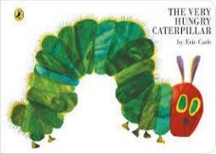  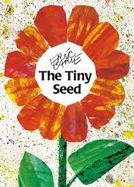  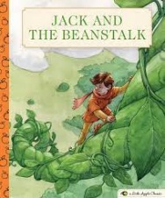  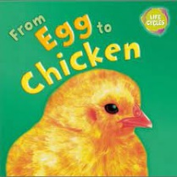
 | lifecycle | Pipping / candling
 | 