 |  |  | What makes me special and belong?  Busy Bees  Knowledge Organiser  Terms 1 and 2  Provocations  Children will be playing and having fun.  They will be learning through their interests.  They will be meeting new friends and learning new routines. We will implement routines, boundaries and rules and develop a sense of belonging to a community of learners.  Children will have access to real life experiences and will be engaged with authentic resources. They will be exploring stories and have the opportunity to retell familiar stories. The children will think about how we are all unique and explore their family, school and community stories. The children will also find out about how families celebrate occasions throughout the year.  You can support your child by:  - reading stories with them about different types of family and by attending our phonics and early maths information evening on Thursday 5th October at 5.30pm in the school hall at our West Wick site.  Mini Enquiries  Who am I and how am I special?  How are we the same and different?  Who is in my family?  What is special about our school?  Who is in our community?  What do we celebrate? | 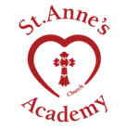  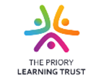
Vocabulary
Key Words | Unique | Environment
 | Family | Community
 | Celebrate | Thankfulness |  | Anchor Texts  Books about families  (Here are some examples, but please use any books you have at home or find at the library.)  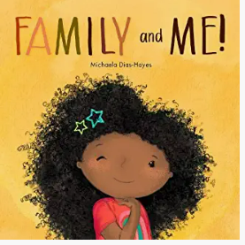  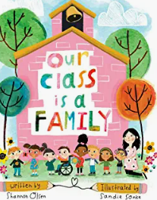  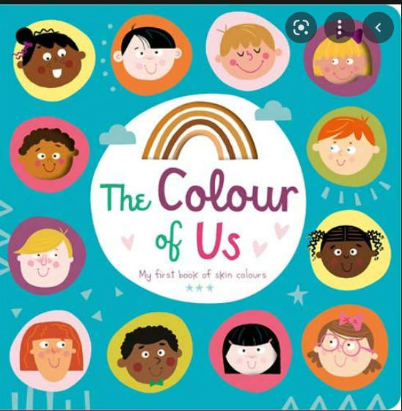
 | Special | Trust
 | 