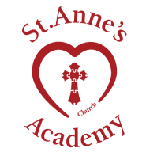
St Anne’s Church Academy @Hewish & @West Wick
Term 4 Newsletter 27th March 2020

Dear Parents and Carers,

The last couple of weeks have been complelty unprecedented and very scary for us all. I have become Head of a virtual school, communicating with everyone via email, Twitter, Whats App and even Zoom ( how many of us had even heard of Zoom before all of this happened?) I miss my St Anne’s family enormously but I am happy to know that all of you are staying safe and well at home. My staff have been amazingly strong and positive and their support for each other makes me so proud. They are working tirelessly from home to check in with you all and provide home learning and many of of us are on site at West Wick caring for the children of Keyworkers.

Love is a key church value for our school and never has it been more important to show love for others than now. Seeing the love around our school family and in the wider community brightens my heart and keeps me going. People reaching and volunteering to help others who are vulnerable.Lets keep doing it. Lets keep thinking of others as we all make sacrifices to get through this. We can get through it together. We appreciate times are very hard for lots of you and we want to help so please contact school by email or phone if you need anything .

Emma Hardy-Smith
Follow me on Twitter @ehardysmith
HOME LEARNING
Thank you to all of you for embracing home learning with your children. We have been absolutely blown away by the number of children accessing Google classroom. At the last count there were 245 children logging on, which is abaolutely amazing!

Our fabulous teaching staff have been uploading lots of learning for their classes and have been thrilled by the amount of children uploading their work. A huge thank you to all of you for supporting us in this new ‘ virtual’ school. Please continue to share your child’s learning via Google classroom and Twitter. It helps us all feel connected to each other. Please do not worry about printing off worksheets from the online platform ( I know lots of you are having printer issues!) the children can simply copy from the screen if they need to. Please contact the school if you need any support with home learning.

A big thank you to all those parents who have sent the school messages of support and kindness.We really are missing our children. We want our children to continue to make progress so everyone is working really hard to ensure that leanirng continues.
Keep up the wonderful work you are all doing!
STAY SAFE

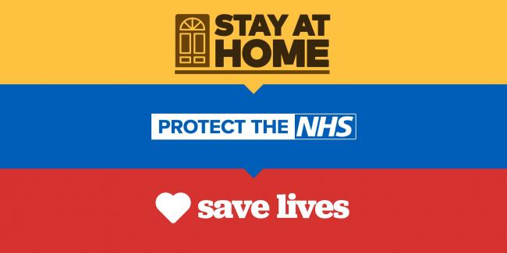

All of us at St Anne’s want to say a huge thak you to all our parent and carers who work for the NHS and Emergency services . We are thinking of you all. Thank you to our key worker families who continue to work to keep the country running. We are proud to support you and provide care for your children so that you can continue to work. Please stay safe and well. Keep up to date with the latest updates:

https://www.gov.uk/coronavirus

